**Project Title: FactoryMethodPatternExample**

**Objective:**

Implement the **Factory Method Design Pattern** to dynamically create different types of documents like Word, PDF, and Excel without using new directly.

**Design Pattern Used:**

**Factory Method Pattern** — defines an interface for creating an object, but lets subclasses alter the type of objects that will be created.

**Implementation Overview:**

1. **Interface:**
   * Document → common interface for all document types.
2. **Concrete Document Classes:**
   * WordDocument, PdfDocument, and ExcelDocument implement Document.
3. **Abstract Factory Class:**
   * DocumentFactory with abstract method createDocument().
4. **Concrete Factories:**
   * WordDocumentFactory, PdfDocumentFactory, ExcelDocumentFactory implement the factory method.
5. **Main Class:**
   * Demonstrates object creation via respective factories, and verifies output.

**Benefits of Using Factory Pattern:**

* Promotes loose coupling
* Follows Open/Closed Principle (easy to add new document types)
* Encapsulates object creation logic

**Output Snapshot:**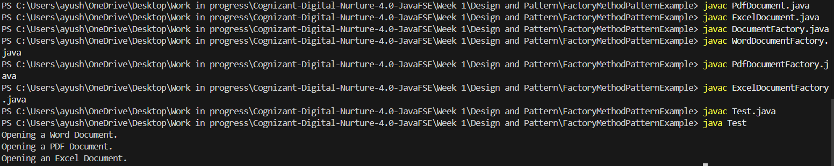

**Conclusion:** The Factory Method Pattern enables scalable and flexible object creation, especially when working with a family of related classes.